AGE-MORTALITY PROFILES IN MAMMALS FROM LA BREA TAR PITS: INSIGHTS INTO POPULATION DYNAMICS, TAPHONOMY, AND STATISTICAL TECHNIQUES

Donald R. Prothero1,2, V.J.P. Syverson3, and Casey Cleaveland2

*1Department of Geological Sciences, California State Polytechnic University, Pomona, CA, 91768;*

*2Department of Vertebrate Paleontology, Natural History Museum of Los Angeles County, Los Angeles, CA, 90007;*

*3Department of Life and Environmental Sciences, University of California, Merced, CA 95343.*

*3*

*Email: donaldprothero@att.net*

*RRH: AGE-MORTALITY CURVES*

*LRH: PROTHERO, D., ET AL.*

**ABSTRACT**

In population dynamics, age-mortality profiles (a histogram showing the proportional mortality in each age class) have long been popular tools for interpreting paleoecology. A typical living population of large terrestrial mammals has its highest mortality rates among juveniles, progressively declining with increasing age. Fossil age-mortality profiles have usually been constructed based on stages of tooth wear throughout ontogeny. In this study we evaluate the potential of constructing these profiles based on size-frequency distributions of limb bone lengths instead of tooth wear. We found that in many cases, the bin size of the histograms gives very different-looking histograms which could result in dramatically different interpretations. For that reason, we explored other statistical methods to objectively determine whether a plot was unimodal or bimodal. In La Brea *Bison antiquus*, tooth wear categories produced an ordinary L-shaped curve, but a curve based on limb bone lengths produced a bimodal pattern, with a larger mode in older juveniles and a smaller mode in adults. We interpret this as a consequence of the fact that mammalian adult limbs stop growing (determinate growth), so the spread of ages within the adult population is not detectable based on limb-bone length. To test whether this result holds in other taxa, we measured and plotted limb-bone lengths for the saber-toothed cat *Smilodon fatalis*, the dire wolf *Aenocyon* *dirus*, and both limb-bone lengths and tooth wear data for the camelid *Camelops hesternus*. We found that most other La Brea mammal limb bone lengths also had a bimodal distribution; the juvenile mode was larger in *C. hesternus* as in *B. antiquus*, while the adult mode was larger in the carnivorans. The tooth wear on all three taxa had the expected unimodal age distribution, but the age resolution was very coarse in the carnivorans. We also used the cumulative density distribution method to see if another technique will objectively distinguish modes in a distribution. We conclude that age-mortality curves compiled from skeletal remains should be treated with caution. Long bone size-frequency distributions should not be directly interpreted as age-mortality curves, and tooth wear should be used only for taxa with enough stages in tooth wear to resolve fine age distinctions. All age-frequency plots should be subjected to statistical tests. In light of these facts, paleoecological interpretations based on these kinds of data should be viewed with caution.

**Introduction**

For the past 70 years, the analysis of large fossil samples using age-frequency profiles has been part of paleoecology (Frison 1978; Reher 1978; Wilson 1980; Klein 1982; Klein and Cruz-Uribe 1983; Stiner 1990, 1994; Steele 2003; Kahlke and Gaudzinski 2005; Wolverton 2006; Lubinski 2013; Discamps and Costamagno 2015). First introduced by Kurtén (1953), Van Valen (1964), and Voorhies (1969), these diagrams plot histograms showing the distribution of age classes of well-sampled and abundant fossil bones of mammals, and compare them to expectations based on different models of how the distribution of age classes changes with different external factors. For example, in the age-frequency distribution of a typical living population of large ungulates today, the youngest juveniles are typically the most numerous age class, since birth rates are high and juveniles are highly vulnerable to predators and other causes of death (Frison 1978; Reher 1978; Wilson 1980; Klein 1982; Klein and Cruz-Uribe 1983; Stiner 1990, 1994; Steele 2003; Kahlke and Gaudzinski 2005; Wolverton 2006; Lubinski 2013; Discamps and Costamagno 2015). Larger subadults and full-grown adults are less vulnerable, so there is only a slight decrease through the intermediate age classes. Very old adults have higher individual likelihood of death, but are relatively uncommon in large ungulate populations, as most of them die of other causes before reaching senescence. As a result, an age-frequency histogram of the population has a single large mode at the youngest end of the distribution and progressively fewer individuals in each older size class (Figure 1, bottom), a shape sometimes called an “L-shaped” profile. After a mass mortality event that indiscriminately kills every member of a population from the oldest to the youngest, the resulting sample of fossils would mirror the age-frequency distribution of the living population exactly. Thus, when this distribution is seen in a fossil population, it is often thought to indicate a catastrophic death assemblage resulting from causes of mass mortality, such as natural disasters (Voorhies, 1969).

By contrast, a “U-shaped” age-frequency distribution has modes in the youngest and oldest age classes (Figure 1, top). As in the L-shaped profile, there are many juveniles, while subadults and adults are scarce; however, the oldest age classes form a second mode. This profile is common in death assemblages, but not in living populations. This profile shape is often taken to represent the consequences of typical predation, as predators preferentially pick off the youngest and oldest individuals. Other age-dependent causes, such as disease, malnutrition, and accidents may follow the same pattern (Steele 2003; Discamps and Costamagno 2015). Such a distribution is characteristic of attritional assemblages, in which the dead from a single population gradually accumulate over a long period of time, producing an assemblage that reflects a combination of the living population age distribution with the probability distribution of mortality by age. Other types of fossil age-frequency profiles have been documented in other taphonomic situations; for example, the Neolithic Star Carr site in Britain was used for antler processing, so it has no juveniles (Klein et al. 1983). However, the “L-shaped” and “U-shaped” profiles are the most common and easily interpreted kinds.

Creating an age-frequency plot requires a large sample of individuals spanning many age classes. Unfortunately, most fossil assemblages are too small for such studies or contain too few of the more fragile juvenile specimens. However, the Rancho La Brea (RLB) tar pits in Los Angeles, California (Marcus and Berger 1984; Stock and Harris 1992; Akersten et al. 1983), with over 3 million fossils, provides a huge sample of every age class for the most common mammals. Few fossil localities preserve such a large sample of well-preserved juvenile bones (especially limb bones) as does La Brea, giving a unique opportunity to look at changes from juveniles to adults. Age-frequency distributions in the most abundant La Brea mammals have been the subject of a handful of studies, mostly based on tooth wear (Jefferson and Goldin, 1989; Binder and Van Valkenburgh, 2010; Galvez and Prothero, 2020).

In 1989, Jefferson and Goldin looked at the tooth wear in the lower jaws of *Bison antiquus,* the most common La Brea bovid. Their results are redrawn here as Figure 2. Using subtle clues of wear on both the deciduous and permanent lower cheek teeth, they were able to subdivide the *B. antiquus* sample into age classes. They found a mode in young juveniles, although the very youngest juveniles were not as common as expected in other types of analyses. They interpreted these results as evidence that many of the bison calves were caught in the tar pits during an annual migration through the La Brea region when the calves were of a certain age.

In another study on *B. antiquus*, Galvez and Prothero (2020) measured and plotted the enormous sample of juvenile bison limb bones in order to find an independent test of the age-frequency distribution reported by Jefferson and Goldin (1989). In all *Bison* limb bones, Galvez and Prothero (2020) found a mode for the young (but not youngest) juveniles, similar to what was found in the tooth wear study, as well as a mode in full-size adult individuals that was not found in the tooth wear data. These data are redrawn in this paper in Figure 3 as both histograms and cumulative density distributions (for justification of these methods, see the discussion in Materials and Methods). Galvez and Prothero (2020) attributed this pattern to the fact that limb bones stop growing when a mammal reaches full adulthood and the epiphyseal caps fuse to the diaphyseal shaft of the limb bone (determinate growth). This cessation of growth in adult limbs bunches up the age-size distribution of all the adult specimens, from prime-aged to elderly, into a few size classes, prohibiting discrimination among adult age classes. Teeth, by contrast, continue to erupt and wear down until death, so a tooth wear comparison can discriminate among different adult age classes. This is the most likely explanation for the difference between the results of Galvez and Prothero (2020) and those of Jefferson and Goldin (1989).

A few other mammals are abundant enough at La Brea for this kind of study: horses (*Equus scotti)*, camels (*Camelops hesternus)*, and the two most abundant predators, the dire wolf (*Aenocyon dirus*) (formerly *Canis dirus*; see Perri et al. 2021) and the saber-toothed cat (*Smilodon fatalis*). Scott and Gust (2020) analyzed the *E. scotti* specimens, finding a large mode in the younger juvenile classes; however, those results cannot be discussed here as they have not been published in full. A detailed study on age-frequency distributions in the predators, *A. dirus* and *S. fatalis*, was conducted by Binder and Van Valkenburgh (2010), comparing tooth wear to pulp cavity closure in the lower jaws; these data are redrawn in Figure 4. They found high mortality among young adult individuals in both samples. Only five wear categories were available for these analyses, as carnivorans have fewer cheek teeth than ungulates (only 3 premolars and 1 molar in felids, 3 premolars and 2-3 molars in canids), so it is harder to subdivide them into age classes by tooth wear. However, the tooth wear age distributions (Fig. 4A) agreed with those based on pulp cavity closure measurements (Fig. 4B) for both *A. dirus* and *S. fatalis*. There have been no previous analyses of age demographics in RLB *C. hesternus*.

In this study, our goal was to determine whether the large mode in mature adult sized limb bones found in RLB *Bison bison* by Galvez and Prothero (2020) is a predictable artifact that should be generally expected in mammalian age-mortality distributions based on bone length, or whether it is a taxon-specific effect. To this end, we collected and compared two different data sets, each measured from RLB specimens of *C. hesternus*, *A. dirus*, and *S. fatalis*: (1) body size frequency distributions based on measurements of limb-bone lengths, and (2) age-mortality curves based on tooth wear and tooth pulp cavity age.

**Materials and Methods**

*Data collection*

Tooth wear for *Camelops hesternus* was measured on all available *C. hesternus* teeth in the Page Museum collections, following the wear criteria defined for *Bison* by Jefferson and Goldin (1989). This broke the sample into a number of age classes defined by tooth wear, comparable to studies done on *Bison* and other large hoofed mammals. For the tooth-based age-mortality curves of *Aenocyon* *dirus* and *Smilodon fatalis*, we used the published results of Binder and van Valkenburgh (2010), redrawn in Figure 4, which were based on a combination of tooth wear and pulp cavity closure.

For the size frequency distributions, large samples of the available unbroken humeri, radii, femora, and tibiae of *Camelops hesternus*, *Aenocyon dirus*, and *Smilodon fatalis* were selected from the collections at the La Brea Tar Pits Museum (formerly the George C. Page Museum of La Brea Discoveries). Using a flexible metric tape measure, we measured the diaphyseal length of all specimens in which both diaphyseal surfaces were preserved. In adult bones, we measured diaphyseal length as the distance between the sutures where the epiphysis fuses to the diaphyseal surface. The epiphyseal caps were excluded from the measurement because they are missing from most juvenile limb bones.

Neither epiphyseal fusion stage nor sexual dimorphism was discernible in these specimens. The epiphyseal fusion method used by some authors to determine age (e.g. Bement and Basmajian (1996) for *Bison antiquus*) rely on the association of bones from a single specimen, and therefore cannot be applied to disarticulated elements like those preserved at RLB. Especially for the extinct taxa, we cannot translate diaphyseal length or epiphyseal fusion into either age in years or sexual maturity.

Similarly, sexual dimorphism could not be identified in these specimens; however, the species used in this study have all been previously demonstrated to have little to no sexual dimorphism in limb bones. *Smilodon fatalis* shows slight sexual dimorphism in the size of cranial and dental features, but not in overall body size or limb dimensions (Christiansen and Harris, 2012). *Aenocyon dirus* shows only slight sexual dimorphism, consistent with the low sexual dimorphism observed in other large canids (Van Valkenburgh and Sacco, 2010; Brannick, 2014). *Camelops* *hesternus* shows no sexual dimorphism in body size (Webb, 1965). *Bison antiquus*, like its living relatives *B. bison* and *B. bonasus* and indeed like most bovids, shows significant sexual dimorphism in various bones (McDonald, 1981). Since discriminating male from female individuals on the basis of isolated disassociated bones is impossible, however, there is no clear way to account for sexual dimorphism. If this signal is visible in our data, we expect that it will appear as a double mode in the distribution of lengths in one or more limb bones of adult *B. antiquus*. We note that Jefferson and Goldin (1989) were unable to identify sexual dimorphism in their tooth wear data set.

*Analysis*

In order to assess the distributions of the body size and tooth age data, cumulative density functions and kernel density estimates were computed. Combining these two different methods of evaluating multimodality allows us to verify our interpretations.

Cumulative frequency distributions, also known as cumulative density functions (CDFs), were created using the R function *stats::ecdf*. First introduced by Harding (1949), CDFs were very popular in sedimentary geology in the 1970s and 1980s thanks to the work of Visher (1969) on sieved sand size distributions. In Visher’s method of plotting the cumulative frequency of each size class on probability paper, a single slope of a line segment on that graph reflected a single unimodal distribution. If there was an inflection in the line, the slopes of the two or three best-fit line segments were interpreted as two or three modes from different sample populations, which overlapped. These were clearly separable on a cumulative frequency plot, but were hard to separate visually on a histogram. CDFs have also been used in paleontology, e.g. in Coombs (1975) to separate overlapping male and female modes in a population of chalicotheres. These methods are rare in recent papers, but Rinehart et al. (2022) argue persuasively that multimodality resulting from the presence of overlapping age cohorts in a population is most easily interpreted from CDFs, including specifically for tetrapod limb bone lengths. We have followed their example by interpreting the inflection points in the CDFs as indicating the presence of multiple modes.

The diaphyseal length measurements were also subjected to Bayesian kernel density estimation (KDE) as implemented in the R function *stats::density*, using Silverman’s heuristic for the bandwidth (Silverman 1981). Using a kernel density estimate instead of a histogram avoids the issue where the apparent size and number of modes changes with different histogram bin sizes (e.g., Scott 1979; Wand 1997). The number of modes was determined based on the kernel density estimate based on the folding test statistic and Hartigan’s dip statistic (equivalent to the excess mass statistic in this case; Cheng and Hall 1998), using R packages *Rfolding* and *diptest* respectively, and 95% probability intervals (posterior probability density) were calculated for each mode.

**Results**

The results are presented in Table 1 and illustrated in Figures 5 through 8. Table 1 reports the tests for modality and the 95% confidence intervals for the detected modes. Figure 5 shows tooth wear in *Camelops*; Figures 6-8 show histograms with overlaid kernel density estimates of limb bone length (top) and cumulative distribution plots of the same data (bottom) for *Camelops*, *Aenocyon*, and *Smilodon* respectively.

For *Camelops*, the tooth wear age-frequency histogram looked much like those of *Bison* and other large hoofed mammals, with most lower jaws representing small individuals interpreted as juveniles, and frequency decreasing with increasing age (Fig. 5). Two modes are present, and the overall distribution is L-shaped. This is also true of the limb bone length histograms of *Camelops* (Fig. 6): they show clear bimodality in the forelimbs (humerus and radius) and the tibia, just as it did in *Bison*, and there are more specimens in the smaller mode than in the larger mode. This is most visible in the femur data (Fig. 6C), where a clear small mode is apparent but two minor adult modes are detected. However, some of this might be due to sampling issues: the samples of all *Camelops* limb bones are relatively small compared to those of both *Bison* in the previous papers, and *Aenocyon* *dirus* and *Smilodon fatalis* in this study. The tests for multimodality indicate that all the *Camelops* limb bone lengths are probably bi- or trimodal, but the p-value for multimodality exceeds 0.05 only for the humeri and tibiae.

For *Aenocyon* *dirus*, the histograms and kernel density distributions of the four limb bones (Figure 7) have fewer juvenile-sized than adult-sized individuals. The juveniles appear as a distinct but small mode in the hindlimb bones and radii, and are rare enough in the humeri that the distribution is instead unimodal, with a single large mode at the upper end of the distribution. Femora are the rarest *Aenocyon* limb bones in this collection, less than half as common as any of the other bones. The tests for multimodality indicate that the humeri are significantly unimodal, radii and tibiae significantly multimodal, and are inconclusive for the femora.

For *Smilodon fatalis* (Figure 8), the histograms of the limb bones show two strong peaks in the humeri and femora and a single peak in the radii and tibiae, but with the juvenile stages rarer than the adults, similar to the *Aenocyon* results. Radii (Fig. 8D) are the rarest of the four *Smilodon* limb bones measured, less than half as common as the other bones. The tests for multimodality indicate that the humeri are significantly multimodal, the tibiae significantly unimodal, and give inconclusive results for the femur and radius.

**Discussion**

The majority of the bone-length distributions display one juvenile/subadult size and one adult size mode, regardless of taxon, which is more easily visible in the cumulative density distribution. This distribution can be explained as the result of an L-shaped age-mortality curve (Fig. 1, bottom) distorted by two factors, both explained below: (a) the absence of very young juveniles and (b) all adults falling into a single mode regardless of their age. Regarding (a), very young juveniles would presumably be less likely to be preserved, due to their more fragile bones, so their absence is unsurprising for the same reason that juveniles overall are probably undersampled (Spencer et al. 2003). This decreases the abundance at the far-left tail of the size distribution. Effect (b) results from the fact that limb bone diaphyseal length does not allow discrimination between prime-age and elderly adults, as mammals reach their mature adult size early and then remain the same size as they get older (determinate growth) (Mumby et al. 2015). The right tail of the theoretically underlying age-mortality distribution, *i.e.,* all adult specimens regardless of age, is thus compressed leftward into an adult mode in the size-frequency distribution. This interpretation is consistent with that of Galvez and Prothero (2020) and leads us to support their previous conclusion that limb-bone size-frequency distributions can be used as a proxy for the age-mortality curve only in the subadult size range.

There are some apparent differences in length distributions between bones within each species. Compare *Camelops* femur vs. all others, *Aenocyon* forelimb vs. hindlimb bones, and *Smilodon* distal vs. proximal elements. The bimodal distribution is evident in some and obscured in others, a pattern unrelated to the sample sizes (given in Table 1). This may be an ontogenetic effect resulting from varying rates of maturation in different limbs. Alternatively, it might reflect a taphonomic effect of the tar pit setting, or even differences in the relative abundance of juveniles in the underlying population age structure. It should be possible to determine this by comparing the relative ages of growth to maximum length in the different limbs of extant mammals. As *A. dirus* has congeneric living relatives, and *Smilodon* has been shown to be ontogenetically similar to other cats (Long et al., 2017), this comparison should be straightforward for the carnivores.

*Variable usefulness of limb-bone distributions*

The comparison between our tooth-wear and limb-bone data sets for *Camelops* (Figures 5 and 6) confirms the observations regarding *Bison* in Galvez and Prothero (2020). Ungulates have many cheek teeth which allow fine-grained discrimination between age classes. Bone length and tooth age both increase in juveniles as they grow larger, but within the adult size range there is no connection between bone length and age, as discussed above. Tooth wear is thus a good data source for reconstructing the adult age-mortality distribution in ungulates and other mammals in which detailed tooth ages can be established, and limb bone length is not as good.

Carnivorans have fewer cheek teeth than ungulates (only three premolars and one molar in felids, three premolars and 2-3 molars in canids), so it is harder to subdivide them into age classes based on dental data. Binder and van Valkenburgh (2010) could establish only five age categories for their tooth wear data analyses, producing very poorly resolved tooth wear ages. For this reason, they based their age classification instead on the percentage of tooth pulp cavity closure, which increases steadily with age and is independent of tooth wear. Comparing their pulp cavity closure distributions (*Aenocyon*, Fig. 2B(i,ii,iii); *Smilodon*, Fig. 2B(iv,v)) to our bone length age distributions (*Aenocyon*, Fig. 7; *Smilodon*, Fig. 8) reveals them to be quite similar, with a lower juvenile mode and a higher adult mode.  As limb bone growth and tooth pulp cavity closure are both processes that approach a determinate maximum at adulthood (ages of epiphyseal fusion and ~90% closure, respectively), it follows that they have similar frequency distributions in the same population. Notably, this is quite different from their tooth wear data, all of which have a single mode in the juvenile range (*Aenocyon*, Fig. 2A(i,ii,iii); *Smilodon*, Fig. 2A(iv,v)). In animals whose teeth do not lend themselves to fine resolution of ages, it thus appears that limb bone length data give a similar distribution to tooth pulp cavity data, and are both better resolved and less diet-dependent than tooth wear. However, that means that *none* of these analysis methods is capable of discriminating between prime-aged and elderly adults, and thus there is no known suitable age proxy for reconstructing the right tail of the age-mortality distribution in these taxa. Evaluating pulp cavity closure in parallel with wear could potentially reconstruct the adult part of the age-mortality distribution, but developing such a method is beyond the scope of this paper.

In view of these results, we question the conclusion of Jefferson and Goldin (1989), in which they attributed the high number of juveniles in their *Bison antiquus* jaw sample to annual herd migration patterns, such as bison being birthed near or migrating through the La Brea at about the same time each year. It now appears that almost any size-frequency histogram from RLB will have a large mode in the young (but not youngest) juvenile age class due to the underlying age-mortality distribution, no matter what ecology a bison, camel, dire wolf, or saber-toothed cat juvenile might have. Detecting the overabundance of any specific juvenile size class in the sample would require a very precise model of the underlying population age distribution, which is probably unachievable for virtually any vertebrate fossil fauna. Thus, inferring migration from the bison size-frequency curve is probably too much of an extrapolation from the data. We note that the very smallest jaws and limb bones are typically underrepresented, but we think that this is explained by the fact that the fragile bones of the youngest individuals are much more likely to be damaged by pit wear and other taphonomic forces.

It may be possible to make more limited inferences about the nature of the age distributions underlying the populations sampled in this study. While bimodal distributions are common to all three taxa studied, the juvenile mode is generally larger in *Camelops* (and in *Bison*), and the adult mode is larger in *Aenocyon* and *Smilodon*. If we accept that the bimodal distributions recovered here are the product of an L-shaped age-mortality curve filtered through a taphonomic lack of very young juveniles and an artifactual compression of all adults into a single mode, and assume that tar-pit mortality was relatively even across age categories other than very young juveniles, then the relative size of the two modes should reflect the steepness of the age-mortality curve. That is, the volume of the "juvenile" mode relative to that of the "adult" mode conveys the extent to which younger individuals were more common in the living population. However, the same pattern could result from bias in either mortality or preservation in the unusual environment of RLB. Again, comparing these results to the population age structures of extant relatives could illuminate differences in the expected shape of the catastrophic age-mortality curves in herd ungulates versus large carnivorans.

**Conclusion**

Age-mortality curves based on tooth wear in the lower jaws in all the sufficiently common La Brea mammals (*Bison antiquus, Camelops hesternus, Aenocyon dirus, Smilodon fatalis*) consistently yields a unimodal distribution, with a primary mode in the juvenile range, and no other significant modes, consistent with a taphonomically filtered “L-shaped” distribution. This suggests that juveniles were far more likely to die and be entrapped in the tar; it is unclear whether this simply reflects the age distribution in the source population, or whether they were more likely to succumb to predation (in the case of prey like bison and camels) or to become entrapped in the tar due to inexperience. Size-frequency curves based on lengths of limb bones, on other hand, consistently yield a second (often larger) mode among limb bones of full-sized adults. It is unlikely that both predators and prey were somehow more vulnerable to death and entrapment as adults than as juveniles. Instead, it seems clear that this unexpected mode is an artifact of the cessation of growth on limbs in adulthood, so that different adult age classes cannot be distinguished based on limb lengths. Thus, limb-bone length histograms cannot be straightforwardly interpreted as population age histograms. However, limb bone sizes yield similar profile shapes to tooth pulp cavity closure for deriving an age-mortality curve among subadult to adult individuals, and may be useful in cases where tooth wear data are unavailable or uninformative.

**Acknowledgements**

We thank A. Farrell and G. Takeuchi for access to the La Brea fossils, and an anonymous commenter at the 2018 Pacific Division AAAS meeting for his insights that led to some of our conclusions in this paper. We thank P. Gillespy and K. Long for allowing us to use their unpublished data. We thank T. Steele, xxx, and numerous anonymous reviewers for reviewing the paper. D. Prothero is grateful to the late L. Marcus for teaching him biometrics, and for also introducing him to the wonders of Rancho La Brea*.*

**References**

Akersten, W.A., Shaw, C.A. and Jefferson, G.T., 1983, Rancho La Brea: status and future: Paleobiology, v. 9, p. 211-127.

Bement, L.C. and Basmajian, S., 1996, Epiphyseal fusion in *Bison antiquus*. Current Research in the Pleistocene, v. 13, p. 95-97.

Binder, W.J., and Van Valkenburgh, B., 2010, A comparison of tooth wear and breakage in Rancho La Brea cats and dire wolves across time: Journal of Vertebrate Paleontology, v. 30, p. 255-261.

Brannick A.L., 2014, Shape evolution and sexual dimorphism in the mandible of the dire wolf, *Canis dirus*, at Rancho La Brea: Unpublished M.S. thesis, Marshall University.

Cheng, M. Y.., and Hall, P., 1998, Calibrating the excess mass and dip tests of modality: J. R. Statist. Soc. B, v. 60(3), p. 579-589.

Christiansen, P., and Harris, J.M., 2012, Variation in craniomandibular morphology and sexual dimorphism in pantherine and the sabercat *Smilodon fatalis*: PLOS ONE, <https://doi.org/10.1371/journal.pone.0048352>

Coombs, M.C., 1975, Sexual dimorphism in chalicotheres (Mammalia, Perissodactyla): Systematic Zoology, v. 24, p. 55-62.

Frison, G.C., 1978, Animal population studies and cultural inference: Plains Anthropological Memoir, v. 14, p. 44-52.

Galvez, S., and Prothero, D.R., 2020, Age-mortality profiles in La Brea *Bison antiquus*: Insights into population dynamics and taphonomy: New Mexico Museum of Natural HistoryBulletin, v. 82, p. 93-97.

Harding, J.P., 1949, The use of probability paper for the graphical analysis of polymodal frequency distributions: Journal of the Marine Biological Association of the United Kingdom, v. 28, p. 141-153.

Jefferson, G.T., and Goldin, J.L., 1989, Seasonal migration of *Bison antiquus* from Rancho La Brea, California: Quaternary Research, v. 31, p. 107-112.

Klein, R.G., 1982, Patterns of ungulate mortality and ungulate mortality profiles from Langebaanweg (early Pliocene) and Elandsfontein (middle Pleistocene), South-Western Cape Province, South Africa: Annals of the South African Museum, v. 90, p. 49-94.

Klein, R.G., and Cruz-Uribe, K., 1983, The computation of ungulate age (mortality) profiles from dental crown heights. Paleobiology, v. 9, p. 70-78.

Klein, R. G., Cruz-Uribe, K., and Wolf, C., 1983, The calculation and interpretation of ungulate age profiles from dental crown heights, *in* G. Bailey (ed.), Hunter-Gatherer Economies in Late Pleistocene Europe: Cambridge University Press, Cambridge, p. 47-57.

Kurtén, B., 1953, On the variation and population dynamics of fossil and recent mammal populations: Acta Zoologica Fennica, v. 76, p. 1-122.

Long, K., Prothero, D., Madan, M., and Syverson, V.J.P., 2017, Did saber-tooth kittens grow up musclebound? A study of postnatal limb bone allometry in felids from the Pleistocene of Rancho La Brea. PLoS ONE 12(9): e0183175.

Marcus, L.F. and Berger, R., 1984, The significance of radiocarbon dates for Rancho La Brea, *in* P.S. Martin and R.G. Klein (eds.), Quaternary Extinctions: A Prehistoric Revolution: University of Chicago Press, Chicago, p. 159-188.

McDonald, J.N., North American Bison: Their Classification and Evolution. Berkeley, University of California Press.

Mumby, H.S., Chapman, S.N., Crawley, J.A.H., Mar, K.U., Htut, W., Soe, A.T., Aung, H.H., and Lummaa, V., 2017, Distinguishing between determinate and indeterminate growth in a long-lived mammal: BMC Evol Biol 15, 214.

Perri, A.R., Mitchell, K.J., Mouton, A., Álvarez-Carretero, S., Hulme-Beaman, A., Haile, J., Jamieson, A., Meachen, J., Lin, A.T., Schubert, B.W., Ameen, C., Antipina, E.E., Bover, P., Brace, S., Carmagnini, A., Carøe, C., Samaniego Castruita, J.A., Chatters, J.C., Dobney, K., Dos Reis, M., Evin, A., Gaubert, P., Gopalakrishnan, S., Gower, G., Heiniger, H., Helgen, K.M., Kapp, J., Kosintsev, P.A., Linderholm, A., Ozga, A.T., Presslee, S., Salis, A.T., Saremi, N.F., Shew, C., Skerry, K., Taranenko, D.E., Thompson, M., Sablin, M.V., Kuzmin, Y.V., Collins, M.J., Sinding, M-H.S., Gilbert, M.T.P., Stone, A.C., Shapiro, B., Van Valkenburgh, B., Wayne, R.K., Larson, G., Cooper, A., and Frantz, L.A.F, 2021, Dire wolves were the last of an ancient New World canid lineage: Nature, 591 (7848): 87–91

Reher, C.A., 1978, Buffalo population and other deterministic factors in a model of adaptive process on the shortgrass plains: Plains Anthropological Memoir, v. 14, p. 23-39.

Rinehart, L.F., Heckert, A.B., and Lucas, S.G., 2022, The utility of probability plotting in palaeobiology: Palaeontology, e12633.

Scott, D.W., 1979, On optimal and data-based histograms: Biometrika, v. 66, p. 605-610.

Scott, E., and Gust, S.M., 2020, Ontogenetic age and sex distribution of *Equus occidentalis* from Rancho La Brea, based on dental and pelvic data: Geological Society of America, Cordilleran Section, Abstracts with Programs, v. 52, no. 4, p. 22.

Silverman, B.W., 1981, Using kernel density estimates to investigate multimodality: J. R. Statist. Soc. B, v. 43, p. 97-99.

Spencer, L.M., Van Valkenburgh, B., and Harris, J. M., 2003, Taphonomic analysis of large mammals recovered from the Pleistocene Rancho La Brea tar seeps: Paleobiology, v. 29(4), p. 561-565.

Steele, T.E., 2003, Using mortality profiles to infer behavior in the fossil record: Journal of Mammalogy, v. 84, p. 418-430.

Stock, C., and Harris, J.M., 1992, Rancho La Brea: A record of Pleistocene Life in California: Natural History Museum of Los Angeles County, Science Series, v. 37, p. 1-113.

Van Valen, L., 1964, Age in two fossil horse populations: Acta Zoologica, v. 45, p. 93-106.

Van Valkenburgh, L., and Sacco, T., 2010, Sexual dimorphism, social behavior, and intrasexual competition in large Pleistocene carnivorans: Journal of Vertebrate Paleontology, v. 22(1), p. 164-169.

Visher, G.S., 1969, Grain size distributions and depositional processes: Journal of Sedimentary Petrology, v. 39, p. 1074-1106.

Voorhies, M.R., 1969, Taphonomy and population dynamics of an early Pliocene vertebrate fauna, Knox County, Nebraska: University of Wyoming Special Contributions to Geology, Special Paper, v. 1, p. 1-69.

Wand, M.P., 1997, Data-based choice of histogram bin width: The American Statistician, v. 51, p. 59-64.

Wilson, M., 1980, Population dynamics of the Garnsey Site Bison: Museum of Anthropology, University of Michigan Technical Report, v. 12, p. 88-129.

FIGURE 1.—Typical age-frequency distributions of "U-shaped" catastrophic (top) and "L-shaped" attritional (bottom) assemblages (redrawn from Steele, 2003).

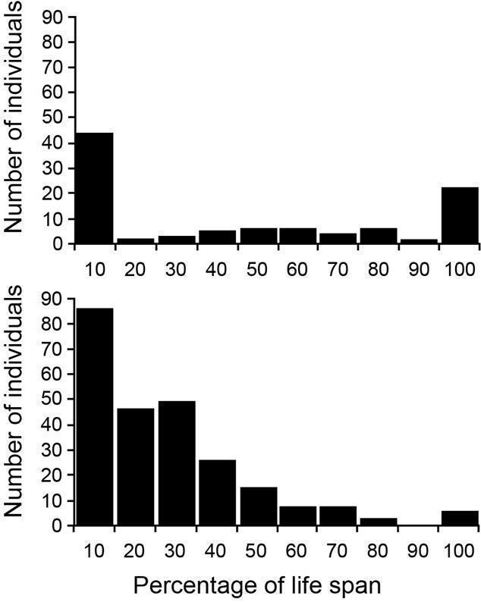

FIGURE 2.—The age-frequency distribution of Rancho La Brea *Bison antiquus* based on analysis of the wear of teeth in lower jaws (redrawn from Jefferson and Goldin, 1989). MNI = minimum number of individuals.

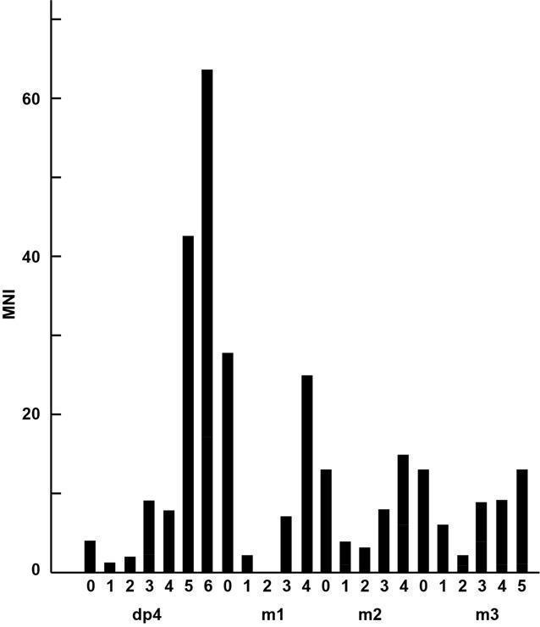

FIGURE 3. Histogram (top row) with overlaid kernel density estimate (solid curves) and cumulative distribution (bottom row) of *Bison* limb-bone lengths from Galvez and Prothero (2020). Note the bimodality of all distributions, as described in the text.

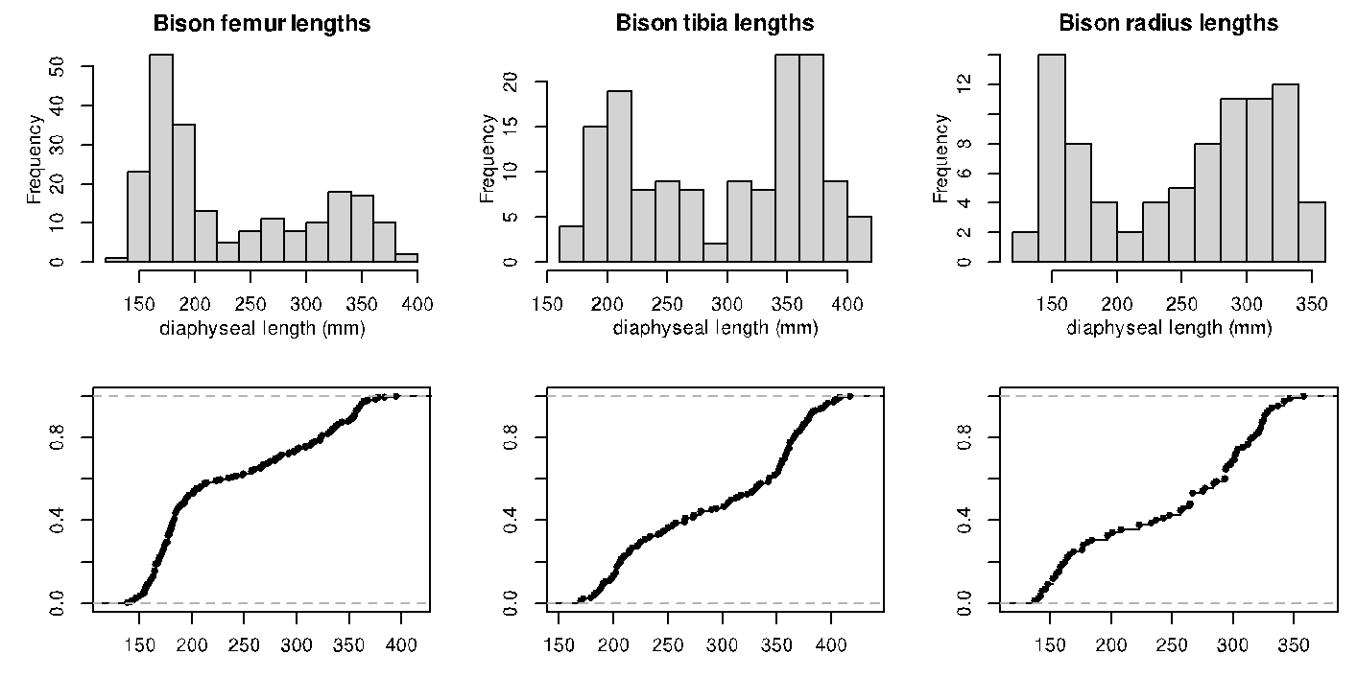

FIG. 4.— Age-frequency histograms of La Brea *Aenocyon* *dirus* and *Smilodon fatalis* jaws, separated by pit. A. (left column), age based on tooth wear, from Figures 2 and 4; i-iii *A. dirus*, iv-v *S. fatalis*. B. (right column), age based on tooth pulp cavity closure, from Figures 3 and 5; i-iii *A. dirus*, iv-v *S. fatalis*. All figures modified from Binder and Van Valkenburgh (2010).

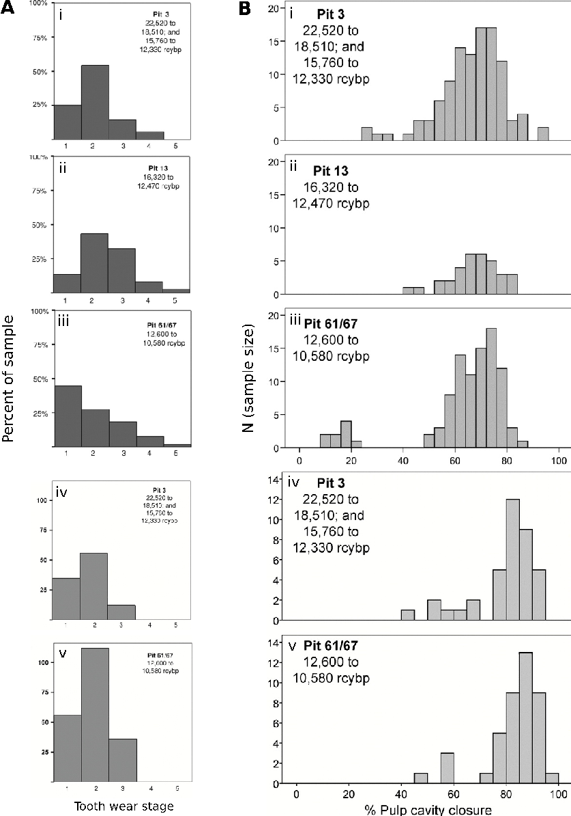

FIG. 5.—Histogram (top row) with overlaid kernel density estimate (solid curve) and cumulative distribution (bottom row) of the RLB *Camelops* jaw and tooth wear data in this study (using the wear categories of Jefferson and Goldin, 1989).

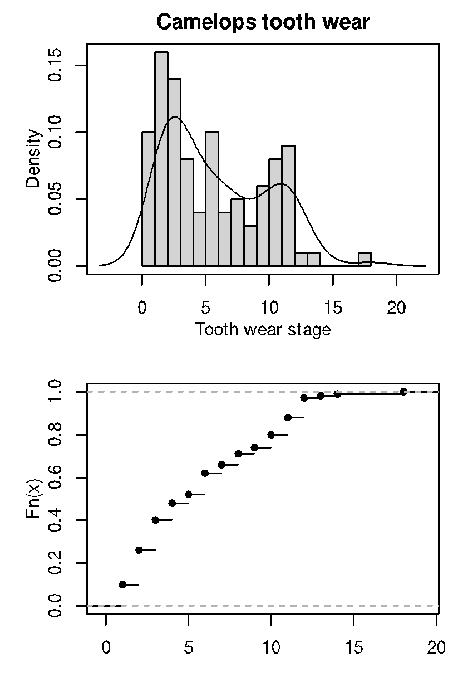

FIG. 6.—Histograms (top row) with overlaid kernel density estimates (solid curves) and cumulative distributions (bottom row) of the diaphyseal lengths of RLB *Camelops* limb bones sampled in this study.

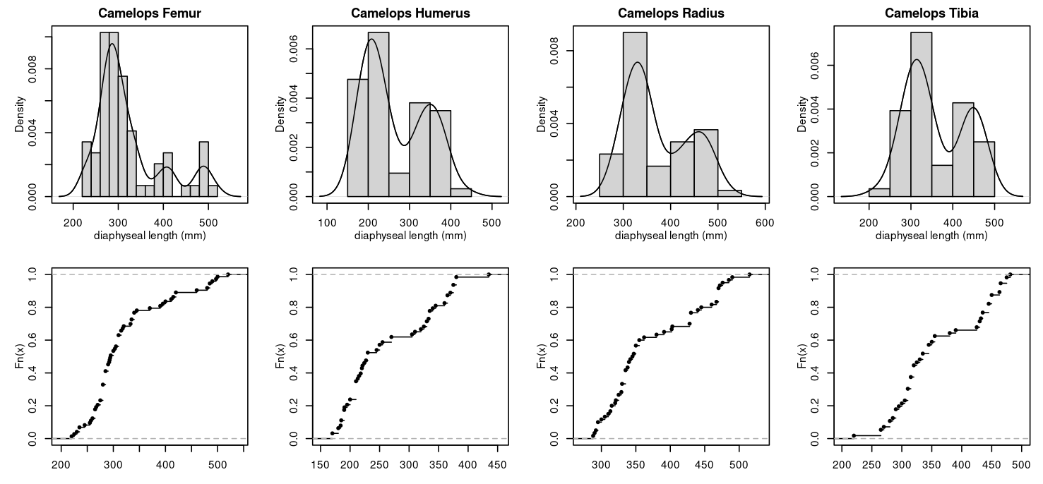

FIG. 7.—Histograms (top row) with overlaid kernel density estimates (solid curves) and cumulative distributions (bottom row) of the diaphyseal lengths of RLB Aenocyon dirus limb bones sampled in this study.

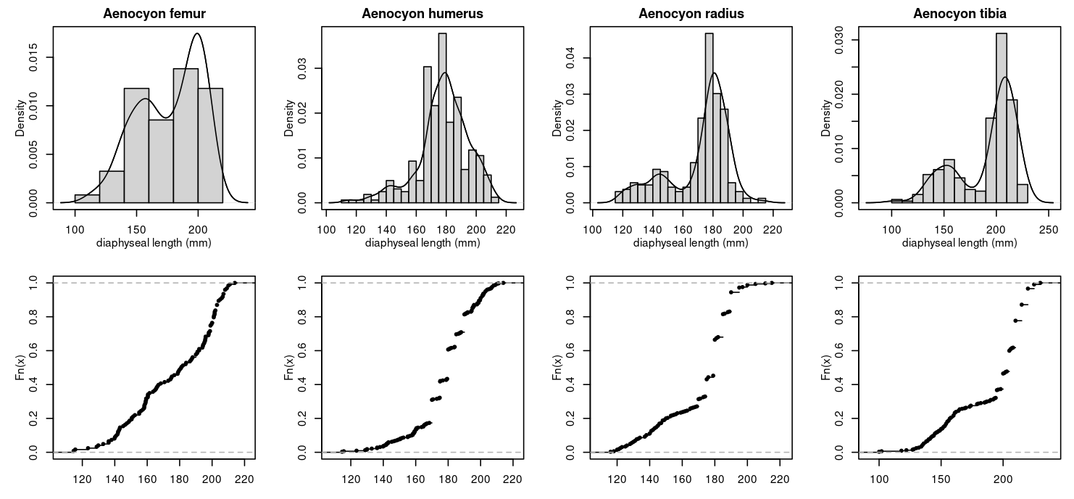

FIG. 8.—Histograms (top row) with overlaid kernel density estimates (solid curves) and cumulative distributions (bottom row) of the diaphyseal lengths of RLB Smilodon fatalis limb bones sampled in this study.

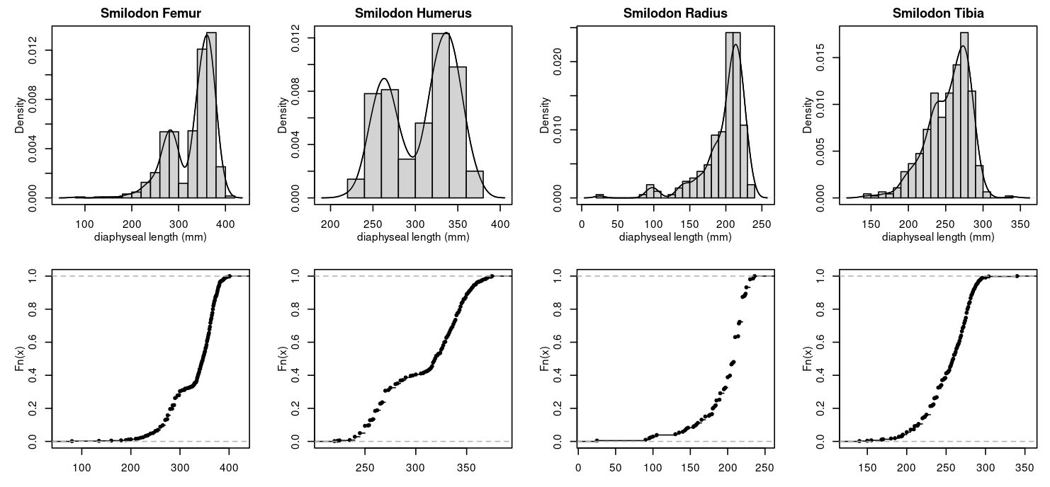

TABLE 1. Specimen counts for each bone measured, number of modes in Bayesian kernel density estimate, and 95% confidence interval (CI) for each mode. If two modes are found with overlapping 95% CIs, they are listed together as a single interval.

|  |  |  |  |  |  | 95% CIs of modes | | |
| --- | --- | --- | --- | --- | --- | --- | --- | --- |
|  |  | N | Dip/Excess Mass Test | Fold Test | Peaks | Peak 1 | Peak 2 | Peak 3 |
| Camelops | Femur | 73 | 0.0411 (p>0.05/n) | Multimodal (p>0.05/n) | 3 | (220,345) | (395,420) | (480,500) |
| Humerus | 63 | 0.0746 (p>0.05/n) | Multimodal (p<0.05/n) | 2 | (170,255) | (310,380) |  |
| Radius | 60 | 0.0639 (p>0.05/n) | Multimodal (p>0.05/n) | 2 | (288,391) | (428,490) |  |
| Tibia | 56 | 0.0863 (p<0.05/n) | Multimodal (p>0.05/n) | 2 | (265,355) | (425,481) |  |
| Aenocyon | Femur | 633 | 0.0345 (p>0.05/n) | Multimodal (p>0.05/n) | 2 | (245,400) | |  |
| Humerus | 500 | 0.0681 (p<0.05/n) | Unimodal (p<0.05/n) | 2 | (240,290) | (305,366) |  |
| Radius | 206 | 0.0677 (p<0.05/n) | Multimodal (p<0.05/n) | 1 | (135,236) |  |  |
| Tibia | 464 | 0.0612 (p<0.05/n) | Multimodal (p<0.05/n) | 2 | (200,296) | |  |
| Smilodon | Femur | 123 | 0.0414 (p<0.05/n) | Unimodal (p>0.05/n) | 2 | (136.23,214) | |  |
| Humerus | 323 | 0.0684 (p<0.05/n) | Multimodal (p<0.05/n) | 1 | (139.83,208) |  |  |
| Radius | 325 | 0.0752 (p<0.05/n) | Unimodal (p<0.05/n) | 2 | (122,157) | (161,197) |  |
| Tibia | 327 | 0.0291 (p>0.05/n) | Unimodal (p<0.05/n) | 2 | (132,170) | (185,230) |  |